Data Privacy Notice

- Your personal data

We collect personal data to help us with the enquiries, bookings, payments, bursaries and marketing. We will request your consent to retain this data. All processing is done only for our legitimate interests as a Data Controller. Our processing of your data is governed by the General Data Protection Regulation (GDPR).

- Seahouses Hostel

Seahouses Hostel is the data controller (contact details below). This means it decides how your personal data is processed and for what purposes.

- How do we process your personal data?

Seahouses Hostel complies with its obligations under GDPR by keeping personal data up to date; by storing and destroying it securely; by not collecting or retaining excessive amounts of data; by protecting personal data from loss, misuse, unauthorised access and disclosure and by ensuring that appropriate technical measures are in place to protect personal data.

We use your personal data for the following purposes:

- To handle and process enquiries
- To process and administer bookings
- To maintain our own accounts and records
- To handle and administer payments
- To process and administer Bursary Fund applications
- To carry out follow up marketing

We will not share your data with any third party

- What is the legal basis for processing your personal data?

When we collect any personal data from you we will ask for your explicit consent
Processing will only take place where it is necessary for our legitimate interests, as listed at (3) above

- Sharing your personal data

Your personal data will be treated as strictly confidential. We will not share your data with any third parties

- How long will we keep your personal data?

We keep data for as long as it is needed for our legitimate interests, and to meet statutory audit requirements for up to 6 years after the calendar year to which they relate.

- Know your rights

Unless subject to an exemption under the GDPR, you have the following rights with respect to your personal data:

- The right to request a copy of the personal data which Seahouses Hostel holds about you
- The right to request that Seahouses Hostel corrects any personal data if it is found to be inaccurate or out of date
- The right to request your personal data is erased where it is no longer necessary for Seahouses Hostel to retain such data
- The right to withdraw your consent to the processing at any time
- The right to request that the data controller provide the data subject with his/her personal data and where possible, to transmit that data directly to another data controller, (known as the right to data portability), (where applicable)
- The right, where there is a dispute in relation to the accuracy or processing of your personal data, to request a restriction is placed on further processing
- The right to object to the processing of personal data, (where applicable)
- The right to lodge a complaint with the Information Commissioner’s Office.

- Further processing

If we wish to use your personal data for a new purpose, not covered by this Data Protection Notice, then we will provide you with a new notice explaining this new use prior to commencing the processing and setting out the relevant purposes and processing conditions. We will seek your prior consent to the new processing.

- Contact Details

To exercise all relevant rights, queries of complaints please in the first instance contact the Warden at Seahouses Hostel, 157, Main Street, North Sunderland, Seahouses, Northumberland NE68 7TU. Tel 07531 305206 or E-mail: seahouseshostel@outlook.com

You can contact the Information Commissioners Office on 0303 123 1113 or via E-mail https://ico.org.uk/global/contact-us/email/ or at the Information Commissioner's Office, Wycliffe House, Water Lane, Wilmslow, Cheshire. SK9 5AF

Updated: 7th July 2025
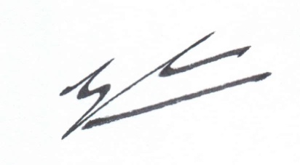 Chair of Trustees – Tony Macpherson

